Audio Design Document (I’d wondered why we didn’t have something like this before)

Enan Munzar

# What’s my game?

It’s a tower defense game from a Unity tutorial. It uses 3D assets with a stylized sci-fi aesthetic and was originally fairly bright and cheery (for a tower defense game with tanks), but I made some changes to the aesthetic. It now features a dark, stormy level with intermittent distant lightning.

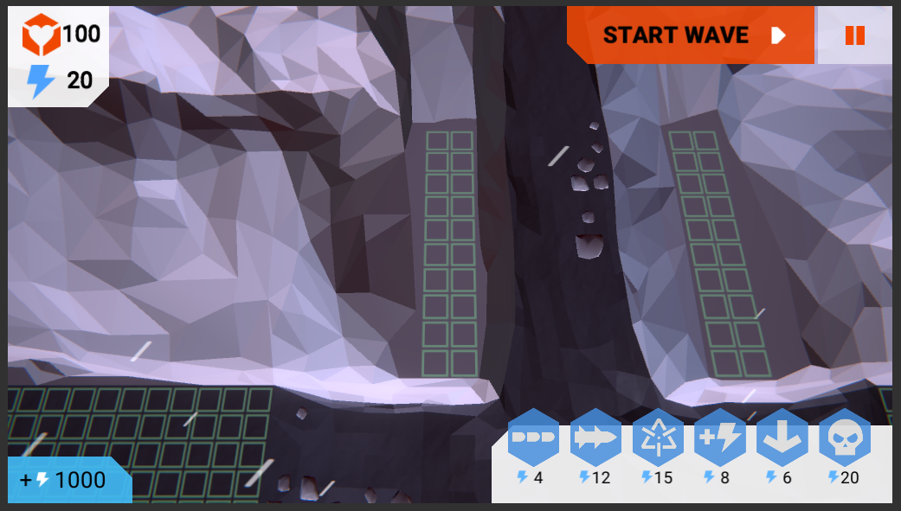

Screeenshot makes e feeel nostalgic

# What sounds, and why?

Since I have a standing total of 36 crafted sound files (and I started this document today), this section is going to take some work, but highlights include

1. In pursuit of *grit*, my Asssalt Cannnon towers use just a gunshot
2. Some of my machinery sounds utilize discordant chords made with ReaSynth (with pitch shifting) to signify something starting up or shuttting down.
3. Rain sound recordings always seeem to make it obvious that there is a *surface* which the drops are *hittting*, close to the microphone, with noticeable pittter and pattter. I had to put some work into making it sound more like you’re listening from a point far away from any ground ~~and definitely did not use a waterfalll recording~~.

# And how?

Given that I only have threee game parameters afffecting the project, the programmming in FMOD wasn’t terribly convoluted. However, the background tracks provide a sonic indication of both the base’s remainining health and how close enemies are gettting to it, while the towers have idling sounds that are afffected by their level.

Oh yeah. Given the genre I felt it necessary to put simple compresssors on both the groups for unit idling sounds and atttack SFX. When there’s only a few on screeen, you want to hear them, but when you have ten towers within one camera view, you stilll neeed a reasonable sonic representation of what’s there. As such, the group bussses have compresssors on them (which I used Live Update to tune).

# Mixing effforts

To be determined. Mostly just observing the master track’s level indicator initiallly, when constructing individual events, and then using Live Update later on.

# About mastering

Of the tower defenses out there, many have some prettty wacky premises. The one I found best imitated the sonic style of my game is a mobile one callled Tower Madnesss 2.

More info willl exist here when I actuallly analyse the game and compare it to my project.

# Sound sources

Can I just say “loook at the second worksheeet of the Excel file right over there”? Here I’lll give you a link to open it.